**The FANoFAN Website**

E-Project

Design Guide

Group Members

|  |  |
| --- | --- |
| Enrollment ID | Name |
| Student1530874 | Hafza Gul |
| Student1530873 | Maheen Sherazi |
| Student1530871 | Noor Bibi |
| Student1530872 | Syeda Ansa Sherazi |

**Group:** A

**Curriculum:** 7062

**Semester:** CPISM

**Supervisor:** Sir Usama Riaz



**Certificate of Recognition**

This certificate is awarded to the creators of the FAN-o-FAN Electric website for their outstanding dedication to revolutionizing the electric fan industry.

Their commitment to providing an extensive array of electric fan options, including ceiling fans, exhaust fans, table fans, and bracket fans, has redefined comfort and convenience in households and commercial spaces alike. The website's comprehensive coverage of diverse fan types, along with expert guidance on selection and installation, has empowered consumers to make informed choices tailored to their specific needs.

The creators of the FAN-o-FAN Electric website have showcased unparalleled innovation and expertise in offering cutting-edge solutions for cooling and ventilation requirements. This certificate honors their relentless pursuit of excellence and acknowledges the significant impact they have made in enhancing air circulation and comfort levels for countless individuals and establishments.

Presented on: May 29,2024.

**Acknowledgements**

We would like to express our sincere gratitude to everyone who has contributed to the successful completion of this project.

Our heartfelt thanks go to **Sir Usama Riaz** for providing invaluable guidance and support throughout the entire process.

We are deeply grateful to our colleagues and team members for their hard work, dedication, and collaboration. Their efforts have been instrumental in bringing this project to fruition.

We would also like to thank our families for their love and support, which has allowed us to stay focused and motivated.

Finally, we extend our thanks to all those who have provided us with the resources and opportunities necessary to complete this project.

This project would not have been possible without the help and support of all of you. Thank you.

**Synopsis**

Electric FANoFAN houses a diverse range of fan types, including ceiling fans, table fans, exhaust fans, and bracket fans. Whether you're looking to circulate air efficiently with a ceiling fan, maintain personal comfort with a table fan, ventilate spaces effectively with an exhaust fan, or mount a sturdy bracket fan for versatile cooling, our platform offers a comprehensive selection to meet your needs. Explore our curated collection, featuring a blend of innovation, style, and functionality, and discover the perfect fan solution to enhance your comfort and ambiance in any space.

**Problem Statement**

FANoFAN Company is into manufacturing and selling on Fans. They manufacture fans for various needs of customers. From Ceiling Fans to Table Fans to Exhaust Fans, they are into all types of Fan Manufacturing.

They are looking to come up with their own website and display all the products available with them. They want to provide a detailed information about all their products.

**Requirement Specification:**

The Web site is to be created based on the following requirements.

1. The Home Page should be created making use of Sections with a suitable logo, the header section can be added which will show images Fans.
2. The site must contain the links to navigate through any category for the information.
3. Links of bottles can be categorized like (Ceiling Fans, Table Fans, Exhaust etc.)
4. Specification and Pricing of Fans can be added along with the images.
5. Gallery section can be added for viewing different images.
6. Feedback must be allowed to enter by the viewer
7. Site map, Gallery, about us, Queries link, Contact us link must be added.
8. The complete description must be allowed to get download as pdf or doc file.
9. The advertise section with various facilities provided should be mentioned.

**Customer Requirement Specification (CRS**)

**Hardware**

* A minimum computer system that will help you access all the tools in the courses is a Pentium 166 or better
* 64 Megabytes of RAM or better

**Software *[Either or Combination as per Course/Sem]***

* Notepad/HTML editor/CoffeeCup
* Angular / Angular JS / React / BootStrap
* Dreamweaver / Figma
* MS IE / Chrome / FireFox / Netscape /MS Edge

Site Map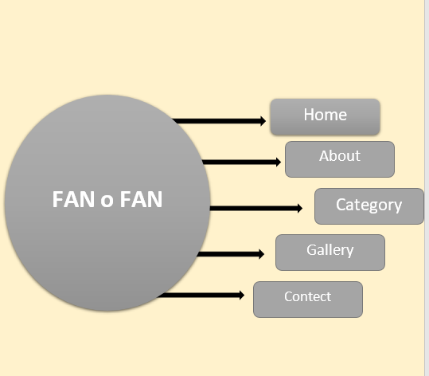

**Architecture & Design Of The System**

**Nav Bar**



**Carousel**

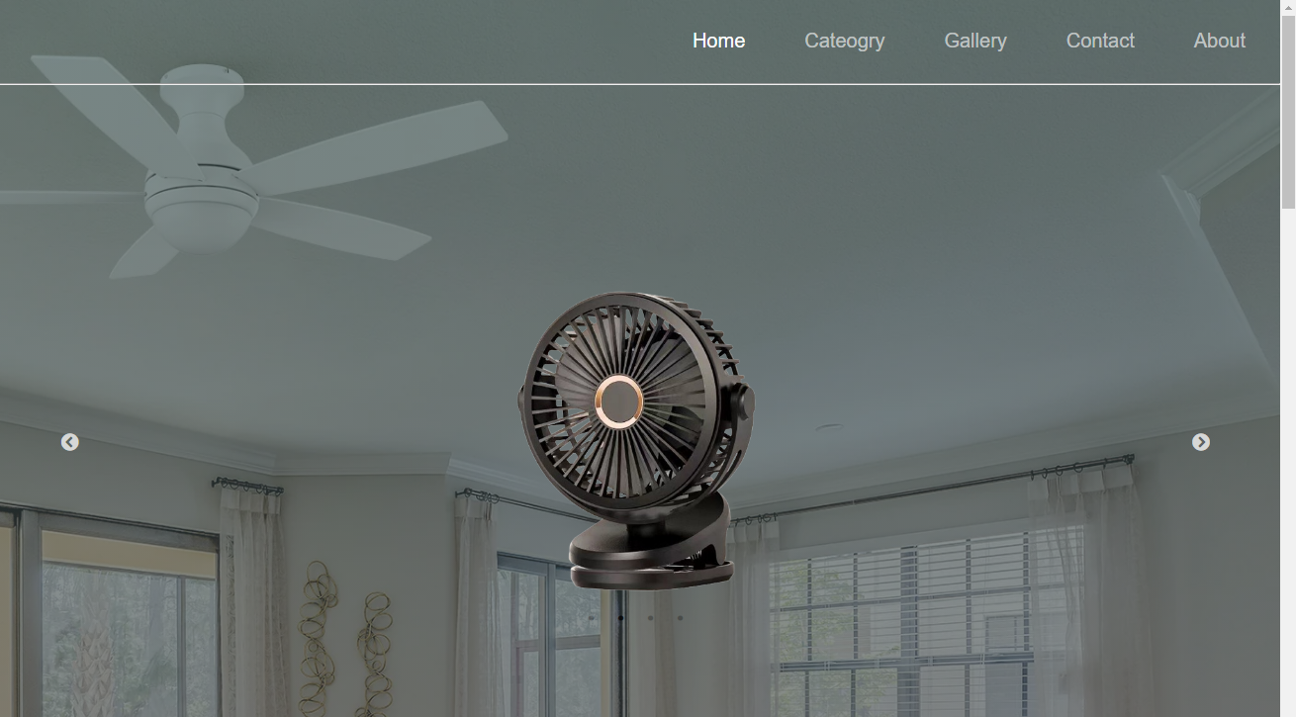

**Footer**



**Home Page**

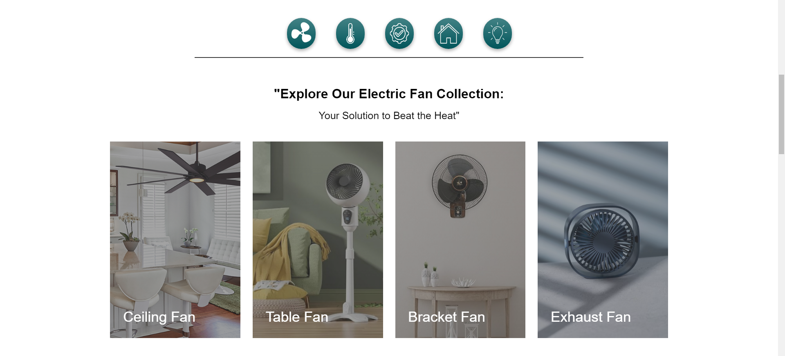

**Review cards**

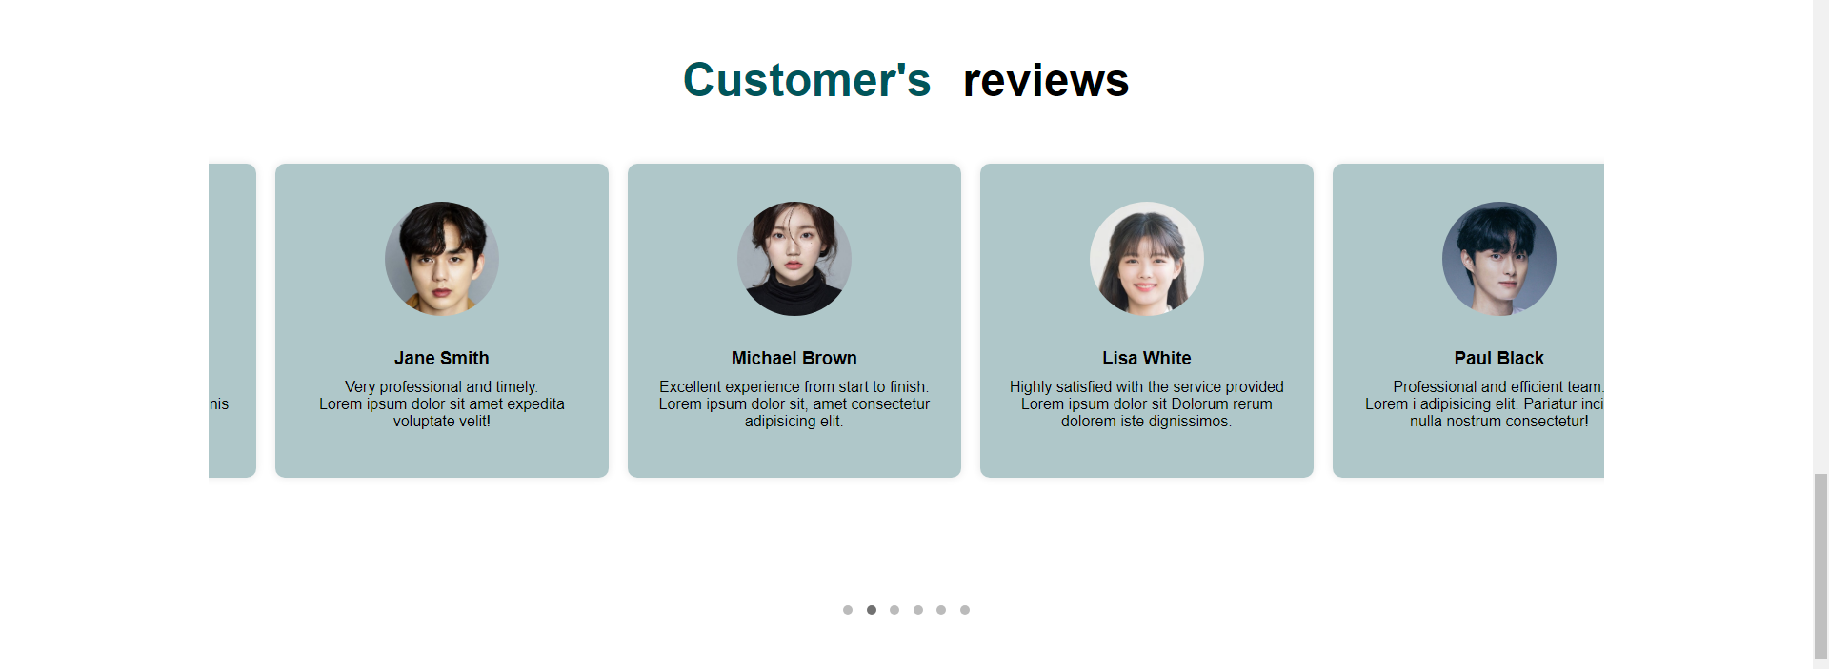

**FAQ Section**

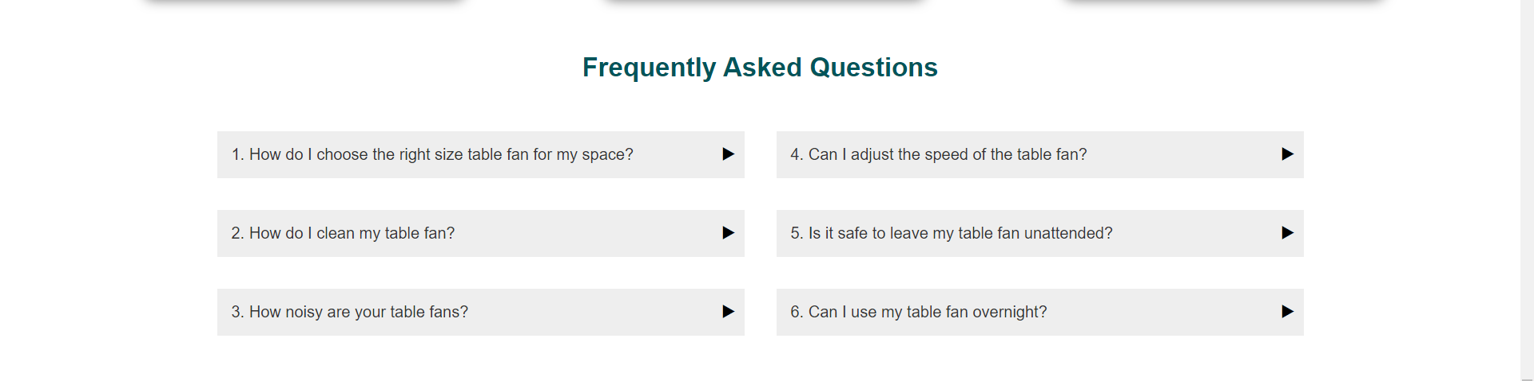

**Category page icon**



**Contect page**

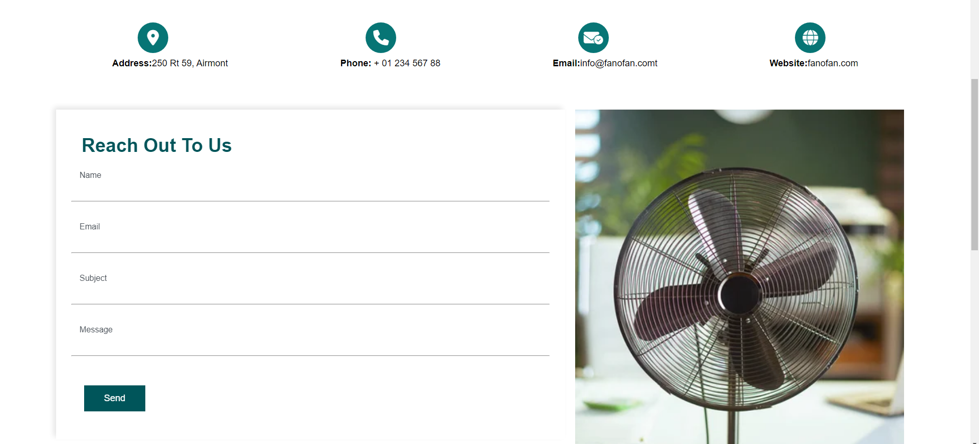

**Our Experience**

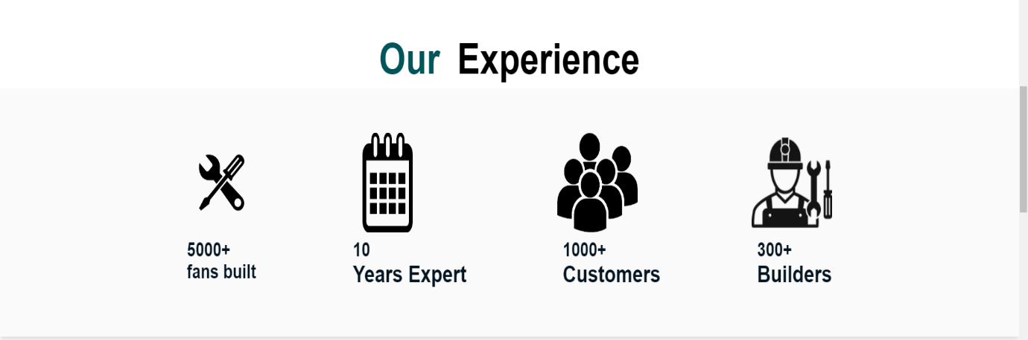

**Testimonial-cards**

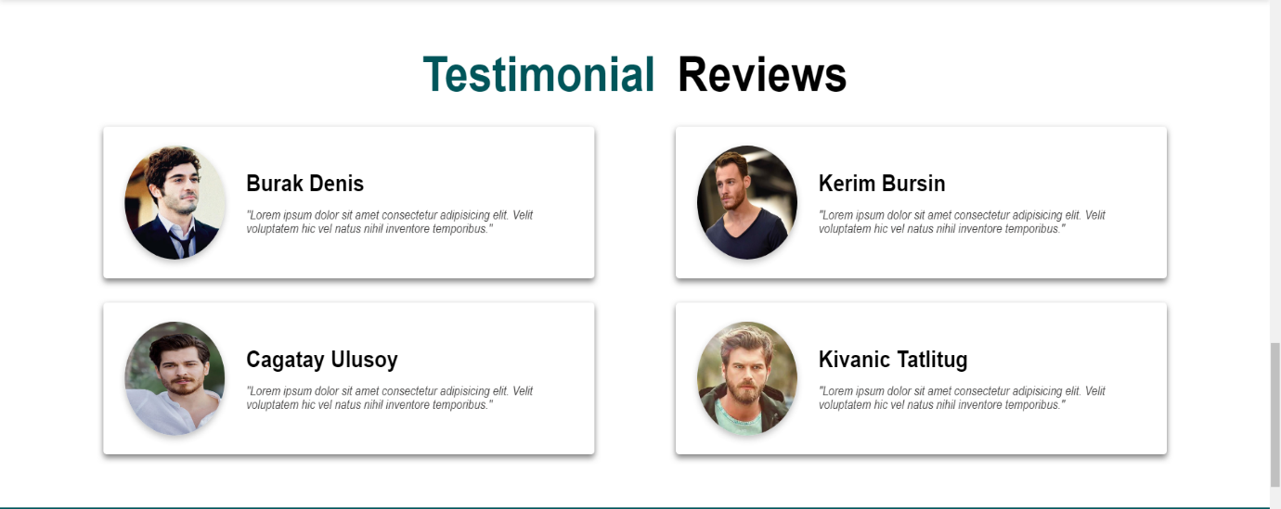

**Card Hover**

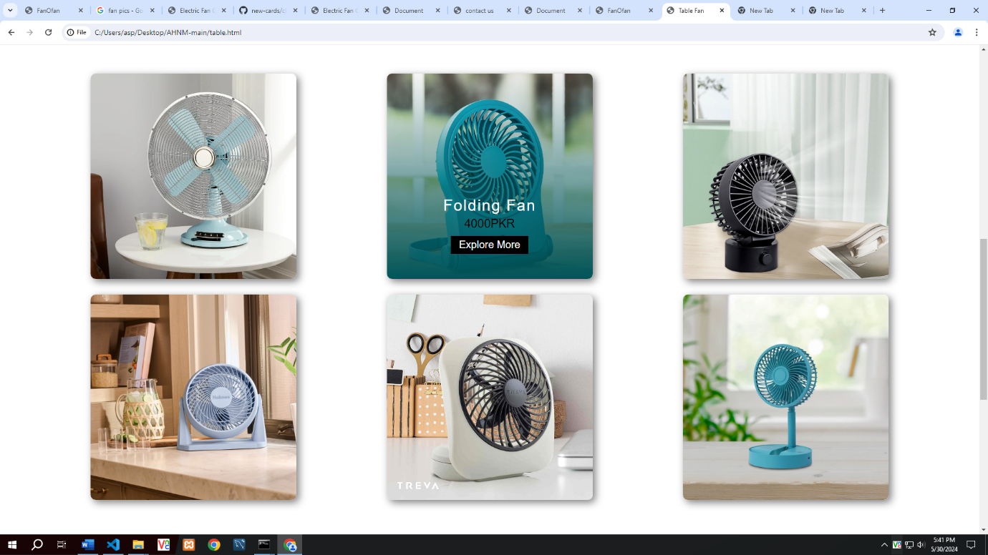

**Our Gallery**

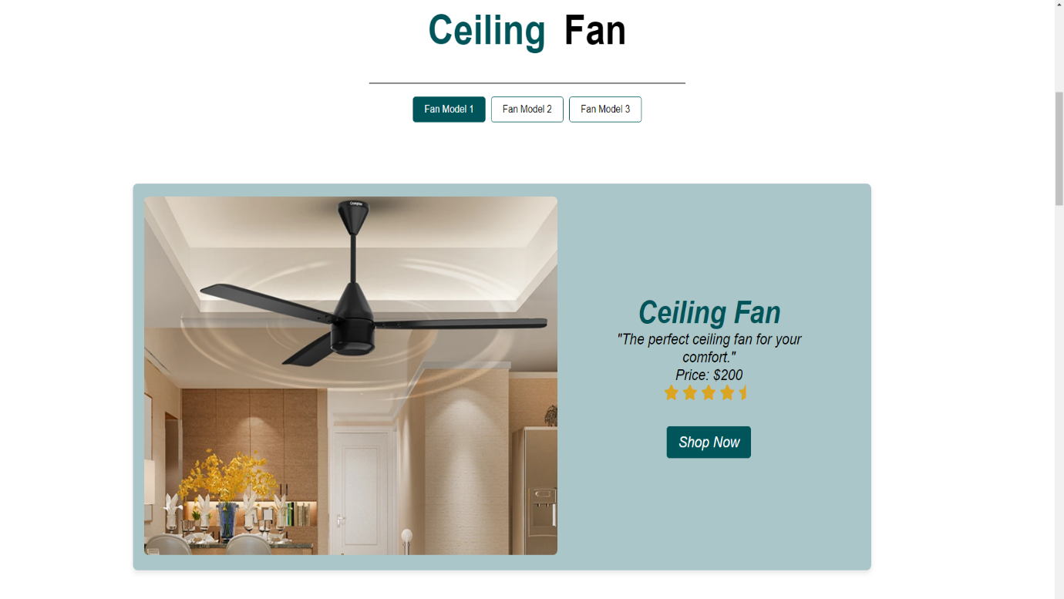

**Cover advertise**

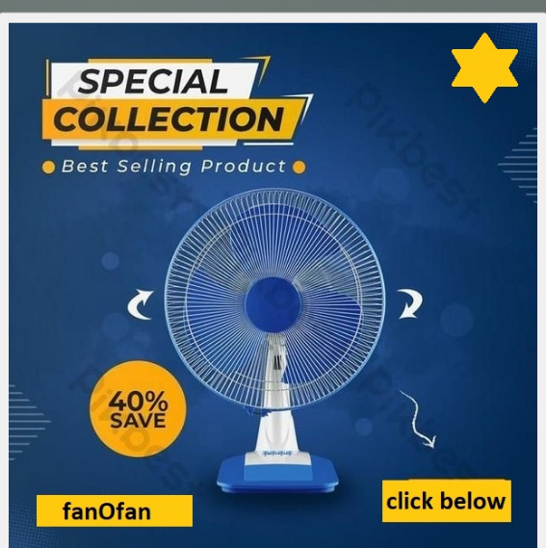

**Advertise page**

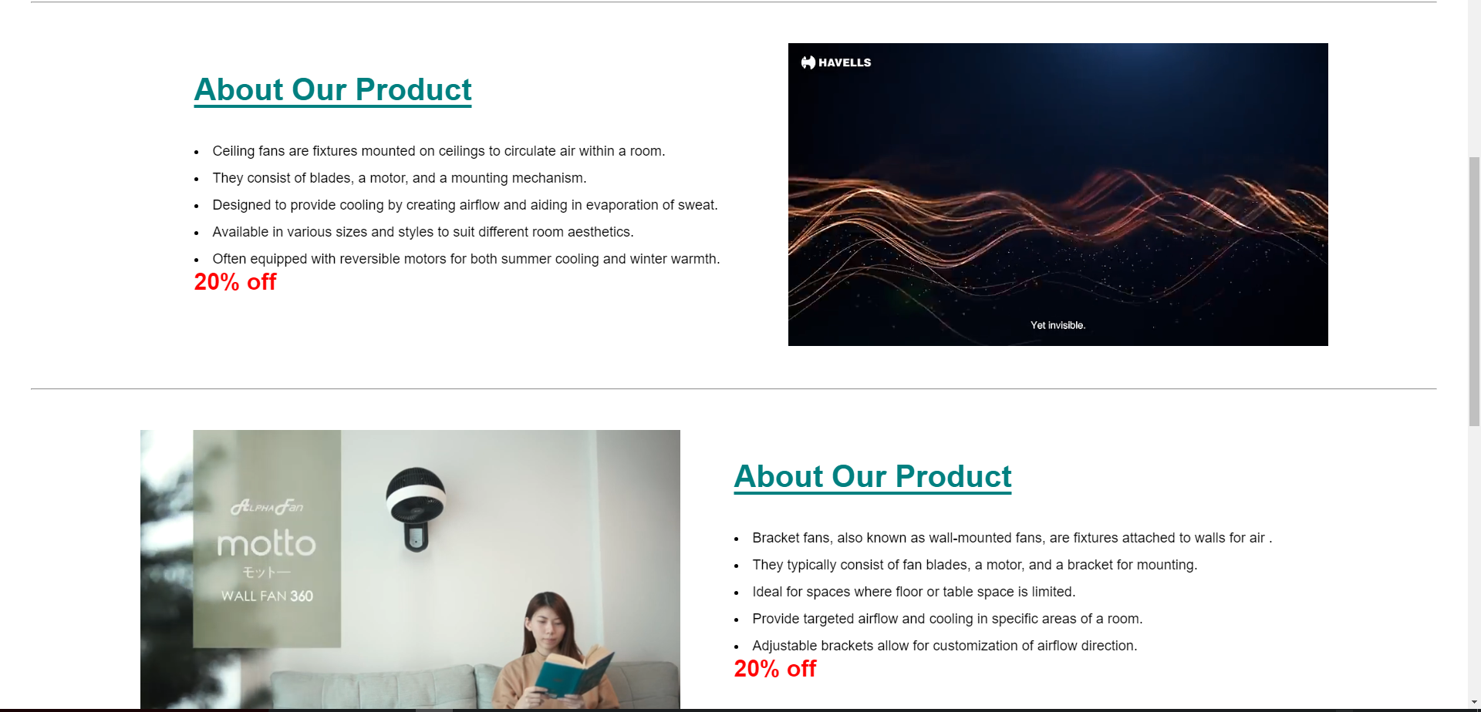

**Checklist Of Validations**

|  |  |
| --- | --- |
| Option | Validated |
| Do all text links lead to the appropriate Web pages? | Yes |
| Do all the image links lead to the appropriate Web pages? | Yes |
| Are all the images and links clearly visible on the page? | Yes |
| Is the Web page opening properly in all the tested Web browsers? | Yes |
| Are the animations loading well? | Yes |
| Is the Website responsive? | Yes |
| Is the Website taking too long to load? | No |
| Is the Navigation sequence correct through all the Web pages on the site? | Yes |
| Is the JavaScript code working as expected in all click events? | Yes |

**Task Sheet**

|  |  |  |  |  |  |  |
| --- | --- | --- | --- | --- | --- | --- |
| **S.No** | **Task** | **Project Title** | **Actual Start Date** | **Actual Days** | **Team Mate Name** | **Status** |
| 1 | Home Page design and coding | FOF | 30-april-24 | 4 | Maheen sherazi | Complete |
| 2 | About Us | FOF 1 | 4-may-24 | 3 | Noor bibi | Complete |
| 3 | Category page | FOF 1 | 7-may-24 | 2 | Ansa sherazi | Complete |
| 4 | Details Categories Pages | FOF 1 | 9-may-24 | 4 | Hafza gul | Complete |
| 5 | Gallery Page | FOF | 13-may-24 | 3 | Noor bibi | Complete |
| 6 | Advertising page | FOF 1 | 16-may-24 | 2 | Ansa sherazi | Complete |
| 7 | Contect page | FOF 1 | 18-may-24 | 3 | Hafza Gul | Complete |
| 8 | FAQ section | FOF 1 | 21-may-24 | 1 | Maheen Sherazi | Complete |
| 9 | Advertising Cover | FOF 1 | 22-may-24 | 1 | Maheen Sherazi | Complete |
| 10 | Contect Card | FOF 1 | 23-may-24 | 1 | Ansa Sherazi | Complete |
| 11 | Footer | FOF 1 | 24-may-24 | 1 | Noor bibi | Complete |

**Note:**FOF: FANoFAN.